- Use the random number generator at this link to generate a random number between 1 and 200,000.?

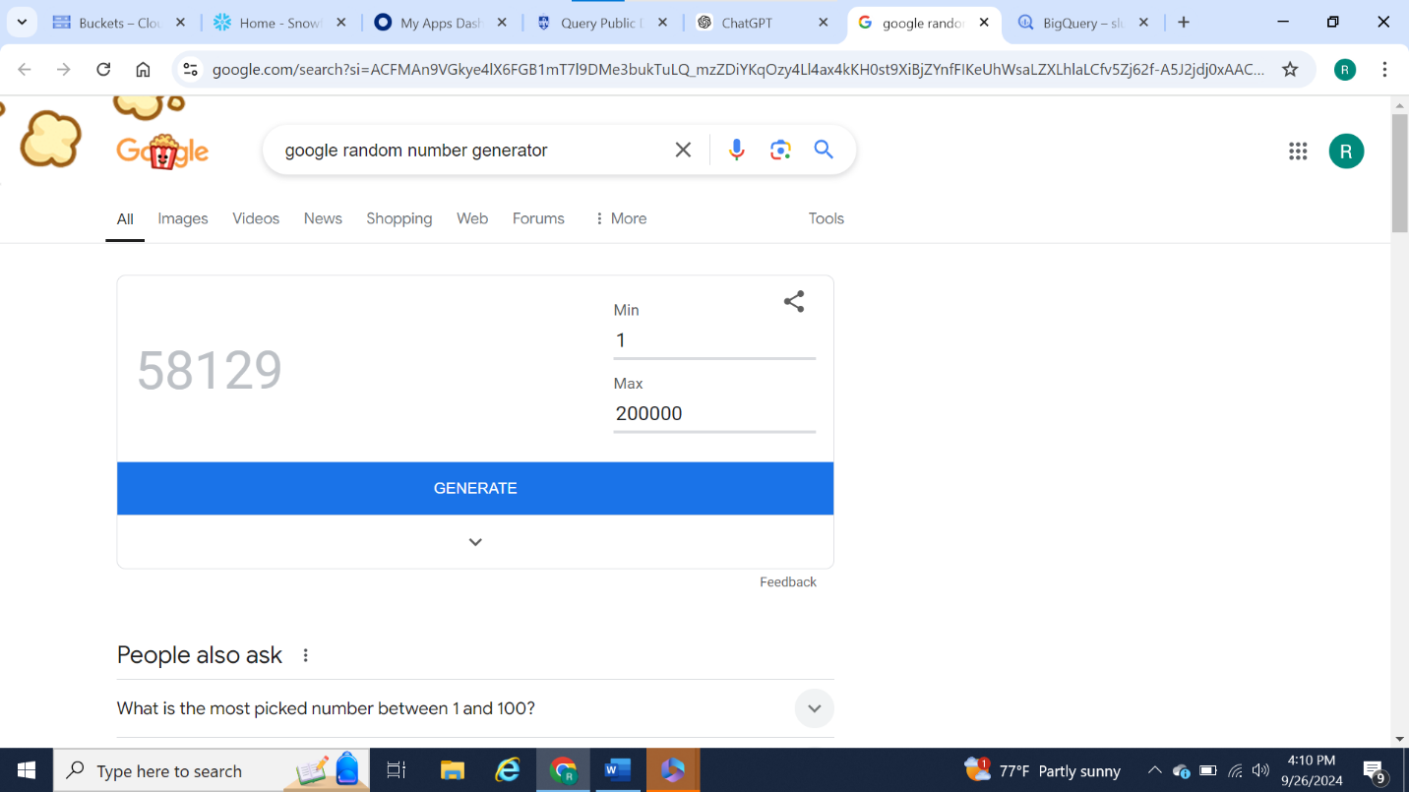

- Run the following query to create the table for which the rest of your assignment will be executed on. Note - replace anything in <brackets> with the appropriate value.
For example, :
CREATE TABLE `<your project name>.<your ACS dataset name>.<make up a table name>`
AS
SELECT * FROM `bigquery-public-data.census_bureau_acs.blockgroup_2016_5yr`
LIMIT 5
OFFSET <your random number>

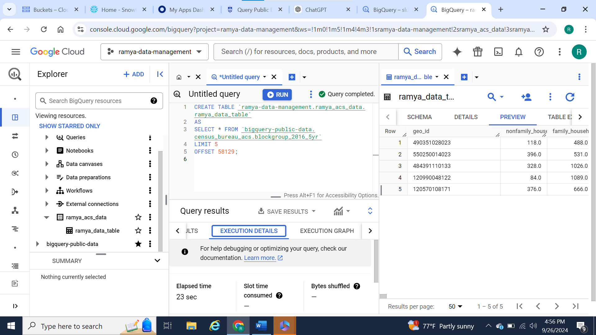

Answer the following questions about your individual subset of the ACS dataset using SQL queries, including text answers plus screenshots showing the SQL code you used to generate the answers and the outputs that were generated. You may use multiple SQL queries for each question if necessary:
What is the total population of the five census block IDs you selected?
Total population:

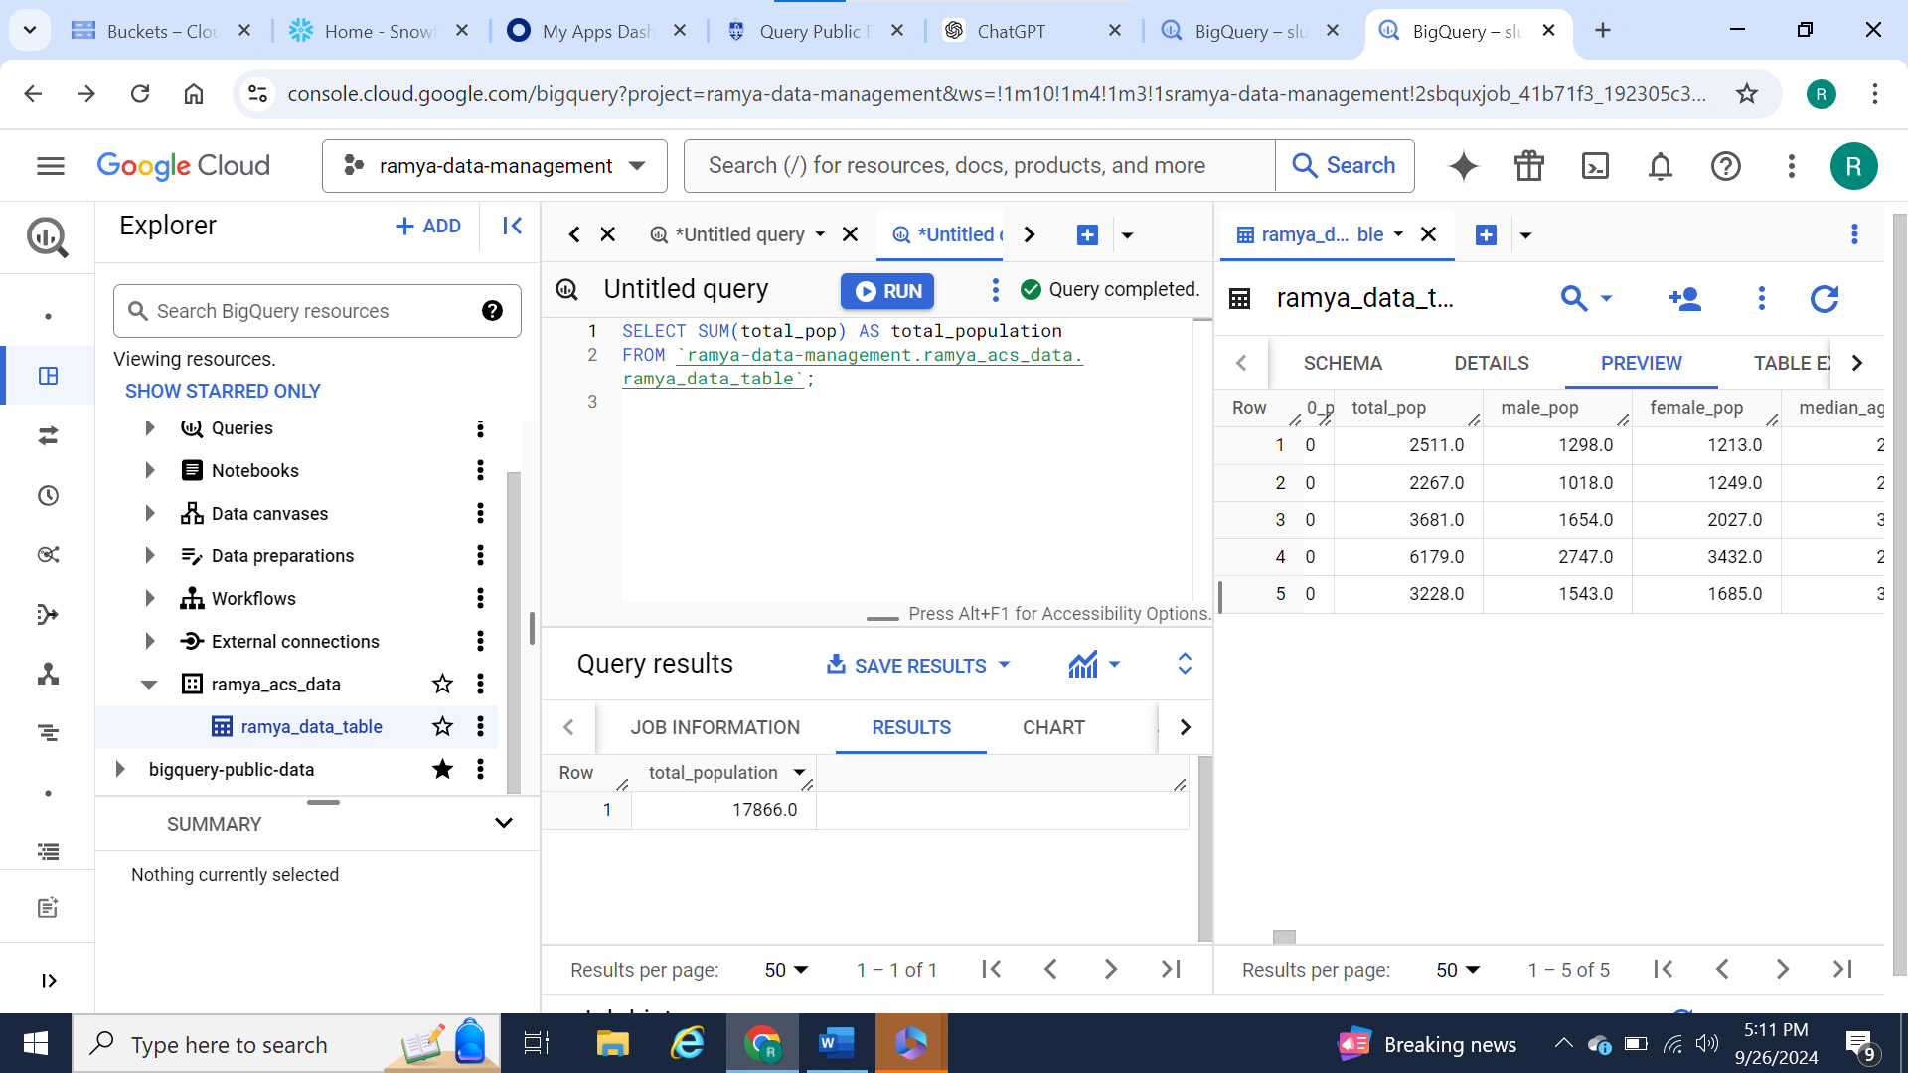

How many total households are in your subset?
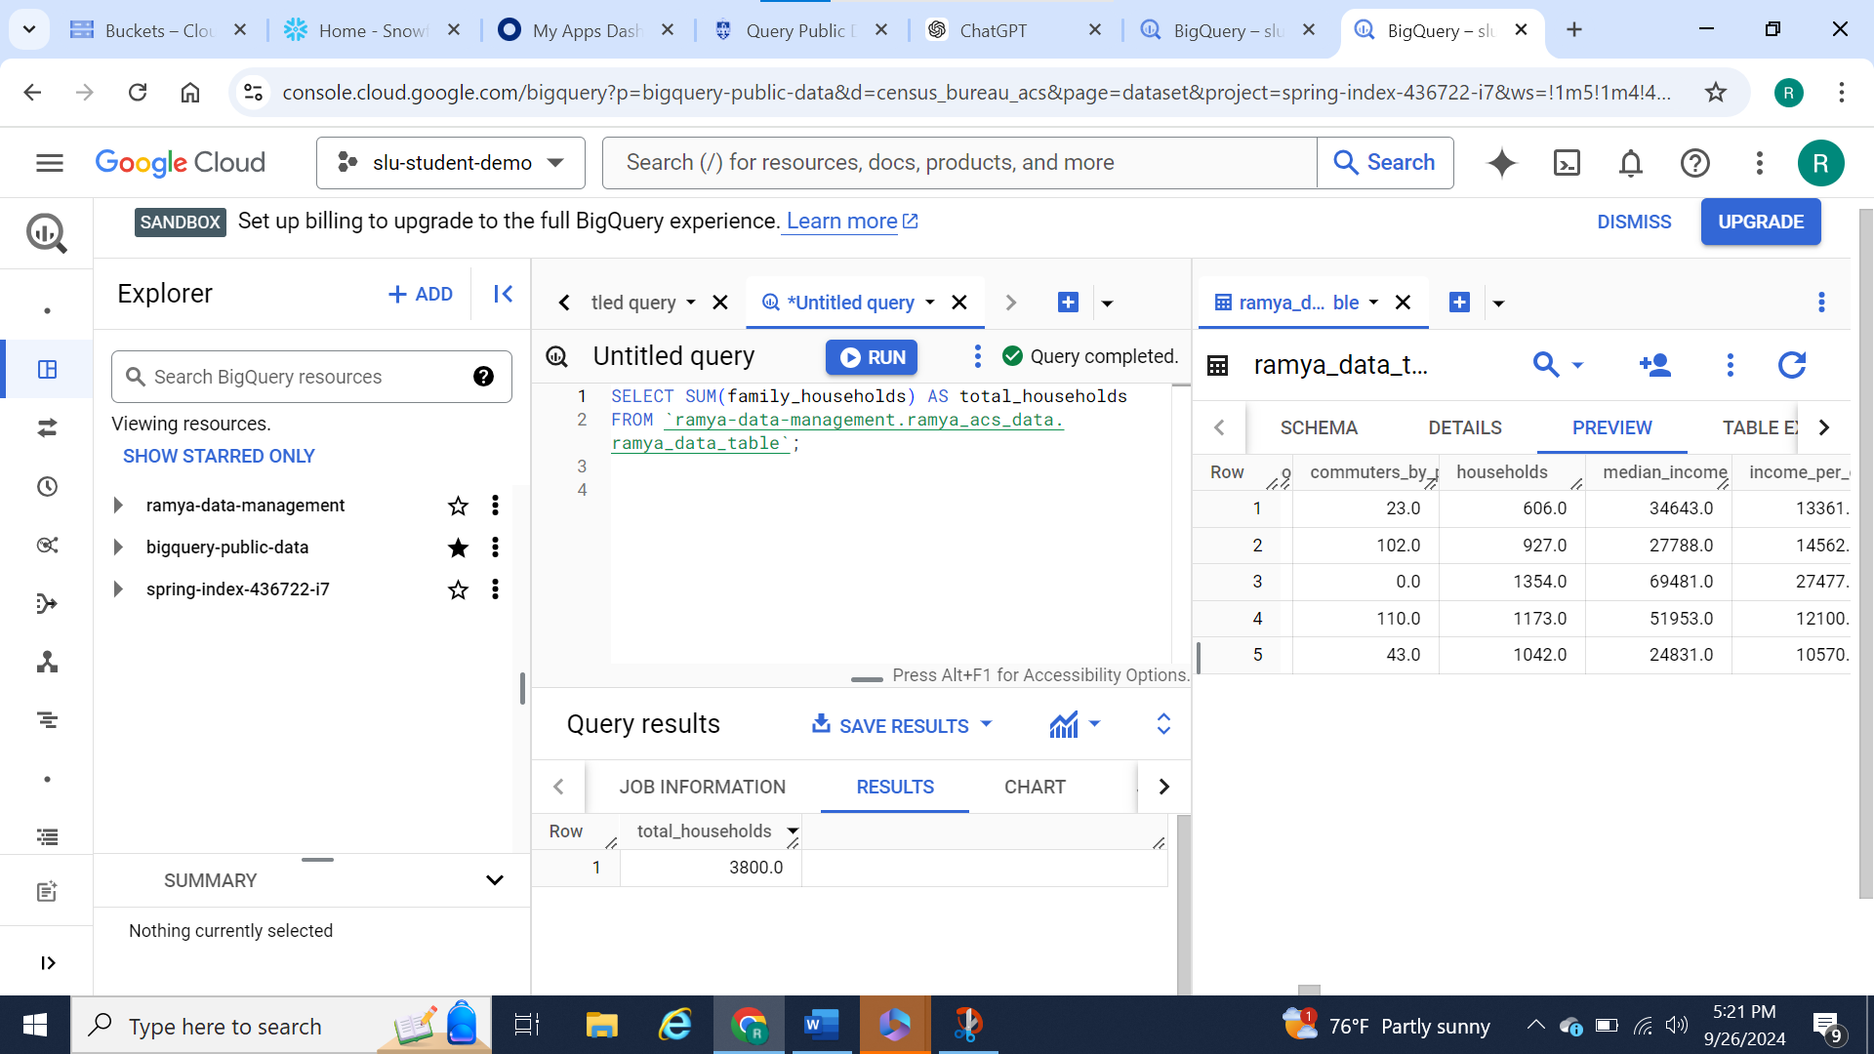
For each geo_id, what percentage of households pay 35% or less of their income in rent? (Hint: Use GROUP BY)
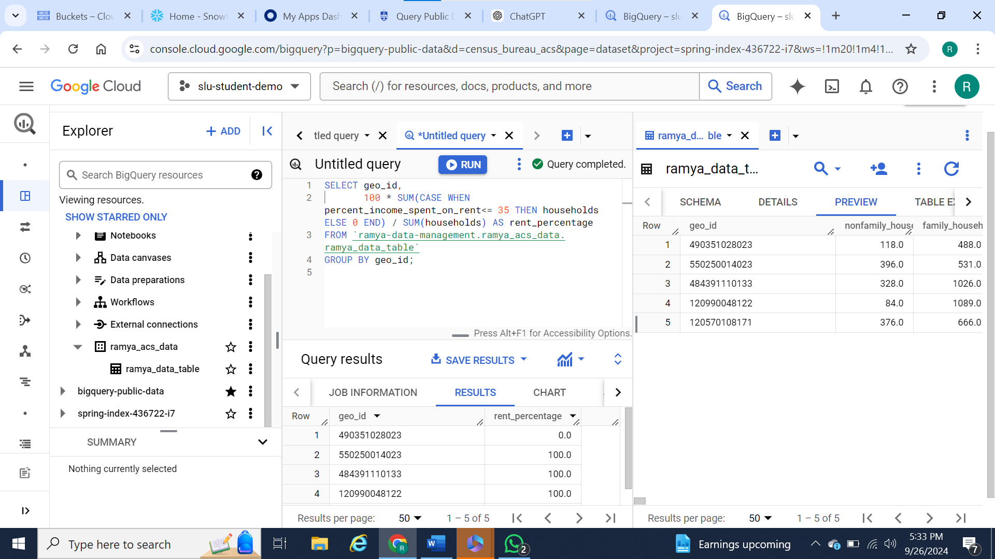
What percentage of the total population of your subset is age 18 or over?

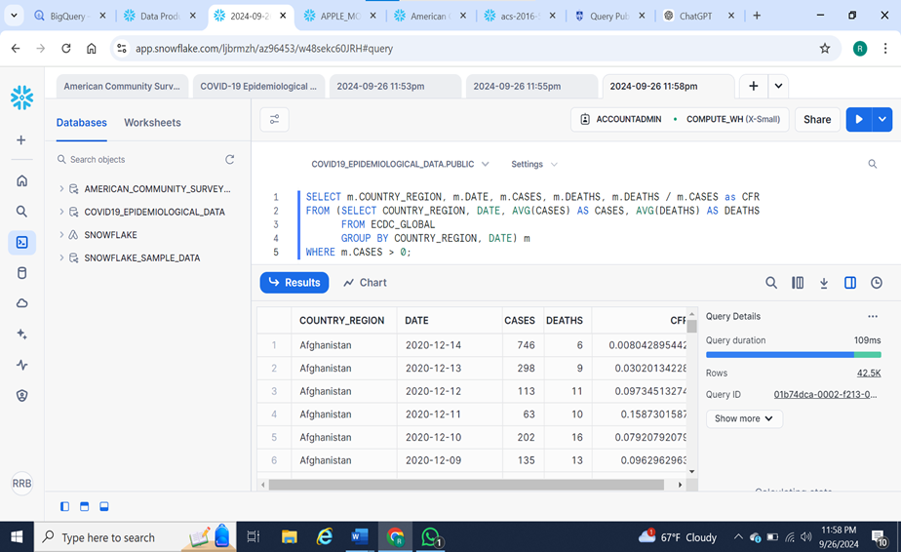

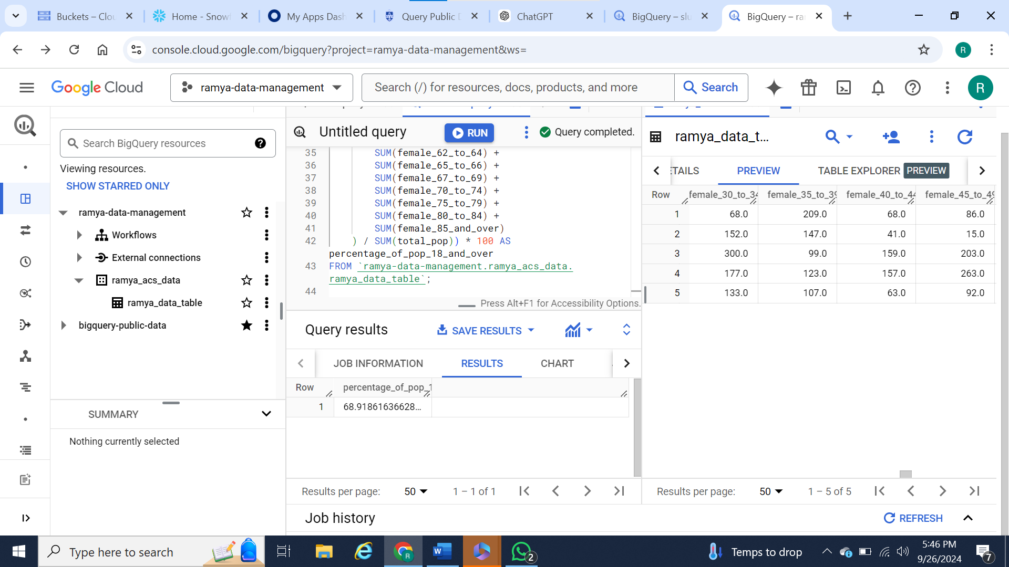

6) Get the ACS data available in Snowflake and preview the data (take a screenshot). Answer the following questions:
Can you perform the same types of queries with this version of the dataset as you did in BigQuery?
If so, create a subset like you did in the requirements above and answer the same questions for this different subset of the data.
If not, explain at a high level what you think you would need to do to the data to get it into a format where you could run the same queries.
(Please note: you do not actually need to perform any data transformations for this. Just describe what you think would need to happen, and move on to question 7.)

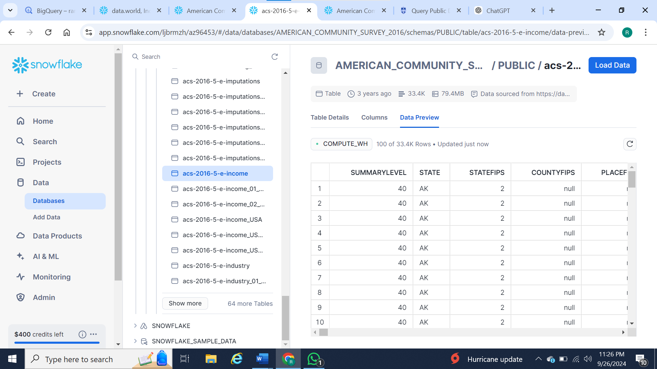

It’s not possible to perform the same types of queries in Snowflake as I did in BigQuery without significantly more effort. The dataset in Snowflake is divided across multiple tables, making it difficult to work with in comparison to BigQuery, where data is more centralized and accessible in fewer tables.
In Snowflake, I would need to join multiple tables together just to recreate a similar dataset to what I had in BigQuery. This would require an understanding of how the tables relate to each other and writing more complex queries, which makes the process more challenging and time-consuming. The scattered organization of the data in Snowflake adds complexity and makes it less user-friendly for running the same type of queries as in BigQuery.
So, while you can achieve the same results in Snowflake as in BigQuery, the process is more involved. You’ll have to spend some time figuring out which tables you need and then structure your queries to join those tables together. It’s not as quick or intuitive as BigQuery, but it’s possible with some extra effort.

7) Pick any other public dataset in Snowflake and come up with three questions of interest that require SQL queries of the same type of complexity as performed on the ACS data in BigQuery and answer them. Take screenshots along the way and explain your reasoning.

I have taken data set of COVID-19 Epidemiological Data from snowflake.

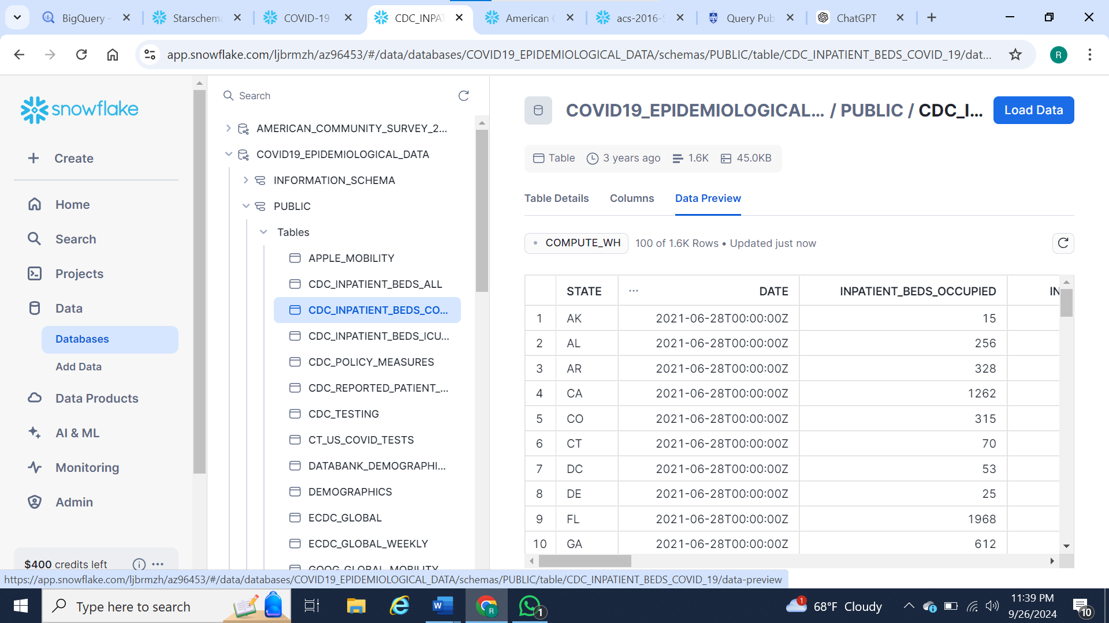
Previewing the CDC inpatient beds occupied dataset to analyze hospital capacity during the COVID-19 pandemic across different states. This dataset provides information on the number of occupied inpatient beds, which helps assess healthcare system strain. The data is filtered by state and date, allowing for state-level analysis of hospital bed utilization. Such insights are crucial for understanding regional healthcare capacity, informing policy decisions, and supporting resource allocation during periods of high demand.

Country and regions

What SQL query can I use to analyze COVID-19 mobility patterns in Virginia, focusing on activities like grocery stores, parks, and workplaces, and filtering for specific trends during the pandemic?

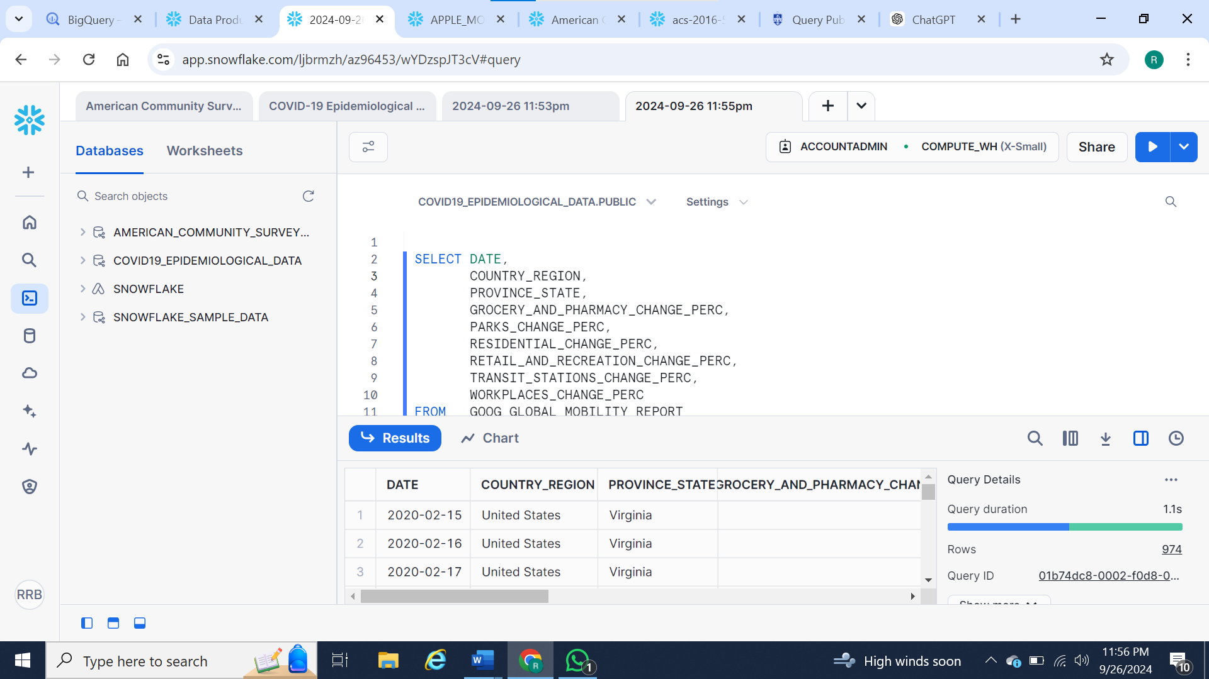

The aim of this query is to analyze the impact of COVID-19 on mobility patterns in Virginia, United States. This data provides insights into how different types of activities (e.g., grocery, parks, workplaces) changed during the pandemic. This information is crucial for understanding behavioral changes in a specific geographic area, aiding in decision-making processes for market analysis, regulatory compliance, and targeting specific regions for intervention or support. The query filters data for Virginia, enabling stakeholders to assess mobility trends specific to this state.
Cases
How can the insights derived from aggregating COVID-19 case data by country inform decisions on allocating healthcare resources to regions with higher case numbers?
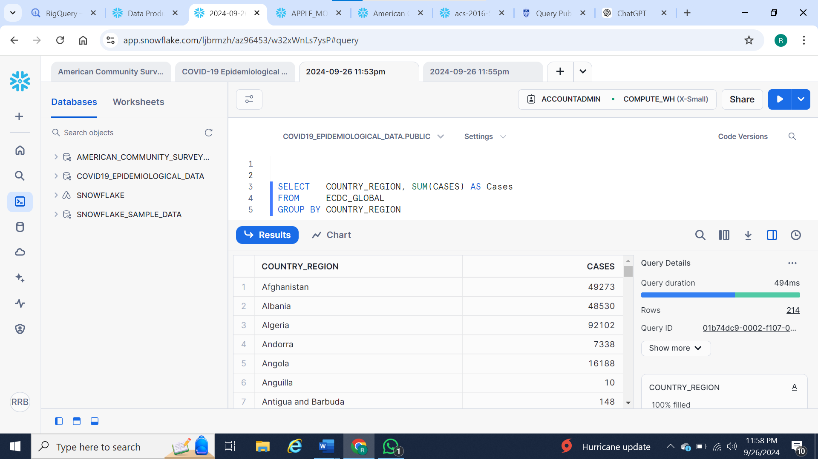

This query efficiently aggregates COVID-19 case data by country, providing a quick and valuable overview for global benchmarking and trend analysis. By grouping cases by `COUNTRY_REGION`, it allows users to compare the impact across different regions, which is essential for identifying areas with higher case numbers that may require further investigation. The query’s fast performance (494ms) makes it suitable for handling large datasets, which is critical in time-sensitive epidemiological analyses. This approach also aids in more focused analyses such as monitoring trends over time, directing healthcare resources to the most affected areas, and serving as a foundation for more detailed explorations, such as visualizing data or calculating case rates per capita.

Deaths
How can I write a SQL query to calculate the COVID-19 Case Fatality Rate (CFR) for each country and date using the EDC_GLOBAL table? The query should aggregate the average number of cases and deaths, filter out any entries with zero cases, and include the computed CFR as a result. What would that query look like?
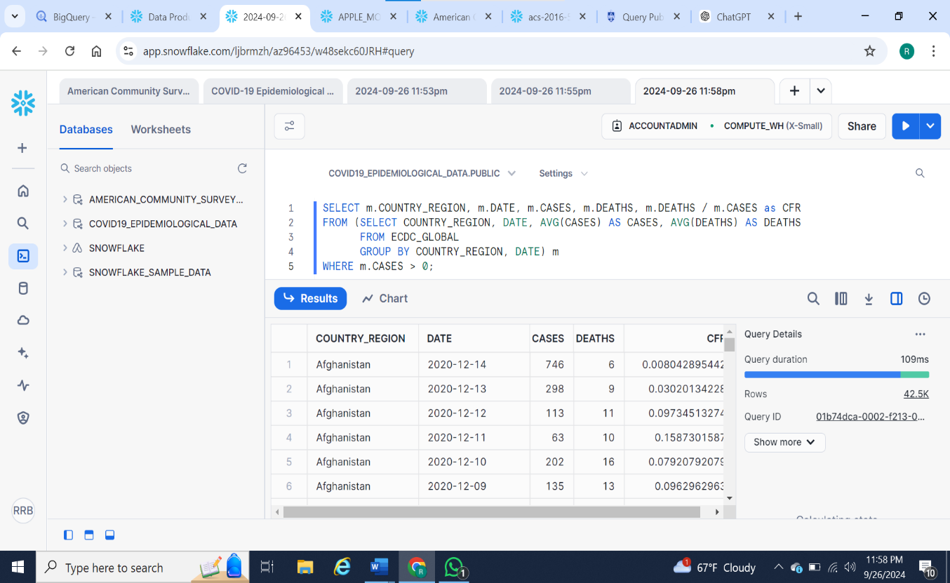

This query calculates the COVID-19 case fatality rate (CFR) by country and date, using data from the `EDC_GLOBAL` table. It aggregates the average number of cases and deaths for each country on specific dates. The query then filters out any rows where cases are zero to ensure valid CFR calculations. The results, as shown for Afghanistan, display the number of cases, deaths, and the corresponding CFR for various dates. The query runs efficiently, processing 42.5k rows in 109 milliseconds. For further analysis, visualizing trends over time or adding additional filtering criteria could enhance insights. Ensuring data quality is also crucial to maintaining accurate CFR estimates.

Citations:

https://app.snowflake.com/marketplace/listing/GZSNZ7F5UH/starschema-covid-19-epidemiological-data?originTab=search&prevCorpus=all&prevQuery=covid%2019%20epidemology%20data

https://app.snowflake.com/marketplace/listing/GZSNZ4PHA6/data-world-inc-american-community-survey-2016?search=american%20community%20survey

